UNIT 1
INTRODUCTION
  - Introduction to Cloud and Cloud Computing:
The term cloud refers to a network or the internet. In other words, we can say that Cloud is something, which is present at remote location. Cloud can provide services over public and private networks, i.e., WAN, LAN or VPN. Applications such as e-mail, web conferencing, customer relationship management (CRM) execute on cloud.

.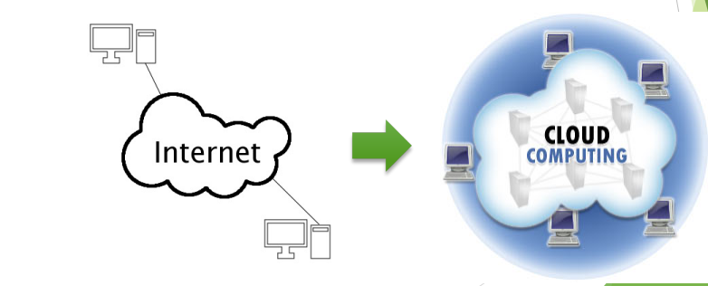

It is a technology that uses remote servers on the internet to store, manage, and access data online rather than local drives. The data can be anything such as files, images, documents, audio, video, and more.
In another word, Cloud computing is Internet-based computing, whereby shared resources, software, and information are provided to computers and other devices on demand, like the electricity grid.
Also, we can define Cloud computing as a style of computing in which dynamically scalable and often virtualized resources are provided as a service over the Internet.
Why Cloud Computing?
Small as well as large IT companies, follow the traditional methods to provide the IT infrastructure. That means for any IT company, we need a Server Room that is the basic need of IT companies. In that server room, there should be a database server, mail server, networking, firewalls, routers, modem, switches, QPS (Query Per Second means how much queries or load will be handled by the server), configurable system, high net speed, and the maintenance engineers.
To establish such IT infrastructure, we need to spend lots of money. To overcome all these problems and to reduce the IT infrastructure cost, Cloud Computing comes into existence.
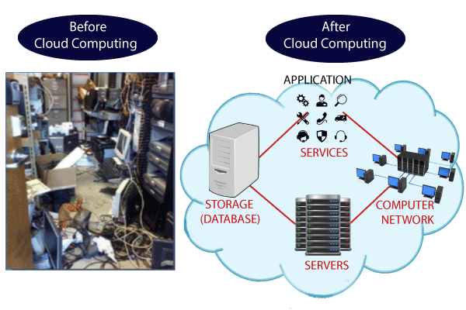
Characteristics of Cloud Computing
The characteristics of cloud computing are given below:
1) Agility
The cloud works in a distributed computing environment. It shares resources among users and works very fast.
2) High availability and reliability
The availability of servers is high and more reliable because the chances of infrastructure failure are minimum.
3) High Scalability
Cloud offers "on-demand" provisioning of resources on a large scale, without having engineers for peak loads.
4) Multi-Sharing
With the help of cloud computing, multiple users and applications can work more efficiently with cost reductions by sharing common infrastructure.
5) Device and Location Independence
Cloud computing enables the users to access systems using a web browser regardless of their location or what device they use e.g., PC, mobile phone, etc. As infrastructure is off-site (typically provided by a third-party) and accessed via the Internet, users can connect from anywhere.
6) Maintenance
Maintenance of cloud computing applications is easier, since they do not need to be installed on each user's computer and can be accessed from different places. So, it reduces the cost also.
7) Low Cost
By using cloud computing, the cost will be reduced because to take the services of cloud computing, IT company need not to set its own infrastructure and pay-as-per usage of resources.
8) Services in the pay-per-use mode
Application Programming Interfaces (APIs) are provided to the users so that they can access services on the cloud by using these APIs and pay the charges as per the usage of services.
  - Advantages and Disadvantages of Cloud Computing
    - Advantages of Cloud Computing:
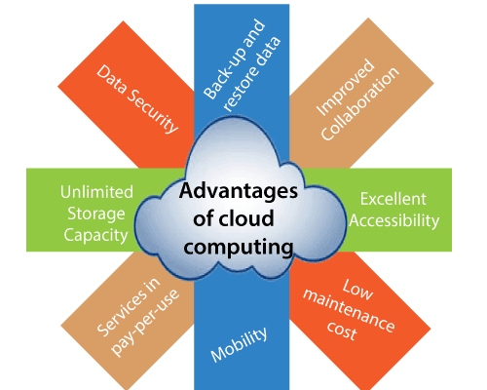
1) Back-up and restore data
Once the data is stored in the cloud, it is easier to get back-up and restore that data using the cloud.
2) Improved collaboration
Cloud applications improve collaboration by allowing groups of people to quickly and easily share information in the cloud via shared storage.

3) Excellent accessibility
Cloud allows us to quickly and easily access store information anywhere, anytime in the whole world, using an internet connection. An internet cloud infrastructure increases organization productivity and efficiency by ensuring that our data is always accessible.
4) Low maintenance cost
Cloud computing reduces both hardware and software maintenance costs for organizations.
5) Mobility
Cloud computing allows us to easily access all cloud data via mobile.
6) Services in the pay-per-use
Cloud computing offers Application Programming Interfaces (APIs) to the users for access services on the cloud and pays the charges as per the usage of service.
7) Unlimited storage capacity
Cloud offers us a huge amount of storing capacity for storing our important data such as documents, images, audio, video, etc. in one place.
8) Data security
Data security is one of the biggest advantages of cloud computing. Cloud offers many advanced features related to security and ensures that data is securely stored and handled.
    - Disadvantages of Cloud Computing
A list of the disadvantage of cloud computing is given below -
1) Internet Connectivity
As we know, in cloud computing, every data (image, audio, video, etc.) is stored on the cloud, and we access these data through the cloud by using the internet connection. If we do not have good internet connectivity, we cannot access these data. However, we have no any other way to access data from the cloud.
2) Vendor lock-in
Vendor lock-in is the biggest disadvantage of cloud computing. Organizations may face problems when transferring their services from one vendor to another. As different vendors provide different platforms, that can cause difficulty moving from one cloud to another.
3) Limited Control
As we know, cloud infrastructure is completely owned, managed, and monitored by the service provider, so the cloud users have less control over the function and execution of services within a cloud infrastructure.
4) Security
Although cloud service providers implement the best security standards to store important information. But, before adopting cloud technology, we should be aware that we will be sending all were organization's sensitive information to a third party, i.e., a cloud computing service provider. While sending the data on the cloud, there may be a chance that were organization's information is hacked by Hackers.
6). Cost concerns
Adopting cloud solutions on a small scale and for short-term projects can be perceived as being expensive. However, the most significant cloud computing benefit is in terms of IT cost savings. Pay-as-you-go cloud services can provide more flexibility and lower hardware costs, but the overall price tag could end up being higher than you expected.

  - History of Cloud Computing:
- Before emerging the cloud computing, there was Client/Server computing which is basically a centralized storage in which all the software applications, all the data and all the controls are resided on the server side.
- If a single user wants to access specific data or run a program, he/she need to connect to the server and then gain appropriate access, and then he/she can do his/her business.
- Then after, distributed computing came into picture, where all the computers are networked together and share their resources when needed.
On the basis of above computing, there was emerged of cloud computing concepts that later implemented.
- At around in 1961, John MacCharty suggested in a speech at MIT that computing can be sold like a utility, just like a water or electricity. It was a brilliant idea, but like all brilliant ideas, it was ahead if its time, as for the next few decades, despite interest in the model, the technology simply was not ready for it. But of course time has passed and the technology caught that idea and after few years we mentioned that:
- In 1999, Salesforce.com started delivering of applications to users using a simple website. The applications were delivered to enterprises over the Internet, and this way the dream of computing sold as utility were true.
- In 2002, Amazon started Amazon Web Services, providing services like storage, computation and even human intelligence. However, only starting with the launch of the Elastic Compute Cloud in 2006 a truly commercial service open to everybody existed.
- In 2009, Google Apps also started to provide cloud computing enterprise applications. Of course, all the big players are present in the cloud computing evolution, some were earlier, some were later.
- In 2009, Microsoft launched Windows Azure, and companies like Oracle and HP have all joined the game. This proves that today, cloud computing has become mainstream.

  - Cloud Computing Architecture:
- As we know, cloud computing technology is used by both small and large organizations to store the information in cloud and access it from anywhere at any time using the internet connection.
- Cloud computing architecture is a combination of service-oriented architecture and event-driven architecture.
Cloud computing architecture is divided into the following two parts -
Front End
Back End
The below diagram shows the architecture of cloud computing -
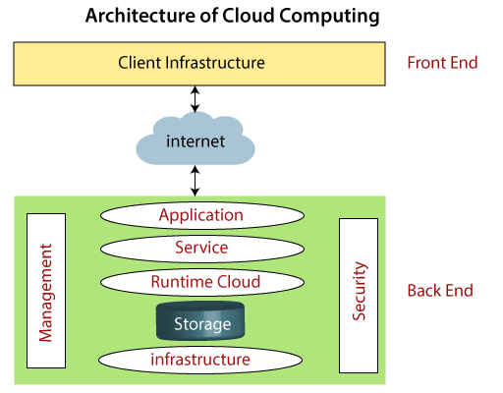
- Front End
- The front end is used by the client. It contains client-side interfaces and applications that are required to access the cloud computing platforms. The front end includes web servers (including Chrome, Firefox, internet explorer, etc.), thin & fat clients, tablets, and mobile devices.
- Back End
- The back end is used by the service provider. It manages all the resources that are required to provide cloud computing services. It includes a huge amount of data storage, security mechanism, virtual machines, deploying models, servers, traffic control mechanisms, etc.
Note: Both front end and back end are connected to others through a network, generally using the internet connection.
  - Components of Cloud Computing Architecture:
There are the following components of cloud computing architecture -
1. Client Infrastructure
Client Infrastructure is a Front-end component. It provides GUI (Graphical User Interface) to interact with the cloud.
2. Application
The application may be any software or platform that a client wants to access.
3. Service
A Cloud Services manages that which type of service we access according to the client’s requirement.
Cloud computing offers the following three type of services:
i. Software as a Service (SaaS) – It is also known as cloud application services. Mostly, SaaS applications run directly through the web browser means we do not require to download and install these applications. Some important examples of SaaS is given below –
Example: Google Apps, Salesforce Dropbox, Slack, HubSpot, Cisco WebEx.
ii. Platform as a Service (PaaS) – It is also known as cloud platform services. It is quite similar to SaaS, but the difference is that PaaS provides a platform for software creation, but using SaaS, we can access software over the internet without the need of any platform.
Example: Windows Azure, Force.com, Magento Commerce Cloud, OpenShift.
iii. Infrastructure as a Service (IaaS) – It is also known as cloud infrastructure services. It is responsible for managing applications data, middleware, and runtime environments.
Example: Amazon Web Services (AWS) EC2, Google Compute Engine (GCE), Cisco Metapod.
4. Runtime Cloud
Runtime Cloud provides the execution and runtime environment to the virtual machines.
5. Storage
Storage is one of the most important components of cloud computing. It provides a huge amount of storage capacity in the cloud to store and manage data.
6. Infrastructure
It provides services on the host level, application level, and network level. Cloud infrastructure includes hardware and software components such as servers, storage, network devices, virtualization software, and other storage resources that are needed to support the cloud computing model.

7. Management
Management is used to manage components such as application, service, runtime cloud, storage, infrastructure, and other security issues in the backend and establish coordination between them.
8. Security
Security is an in-built back-end component of cloud computing. It implements a security mechanism in the back end.
9. Internet
The Internet is medium through which front end and back end can interact and communicate with each other.
  - Difference between Cloud Computing and Grid Computing:
Cloud Computing | Grid Computing
Cloud Computing follows client-server computing architecture. | Grid computing follows a distributed computing architecture.
Scalability is high. | Scalability is normal.
Cloud Computing is more flexible than grid computing. | Grid Computing is less flexible than cloud computing.
Cloud operates as a centralized management system. | Grid operates as a decentralized management system.
In cloud computing, cloud servers are owned by infrastructure providers. | In Grid computing, grids are owned and managed by the organization.
Cloud computing uses services like Iaas, PaaS, and SaaS. | Grid computing uses systems like distributed computing, distributed information, and distributed pervasive.
Cloud Computing is Service-oriented. | Grid Computing is Application-oriented.
It is accessible through standard web protocols. | It is accessible through grid middleware.

  - How does cloud computing work?
- Assume that we are an executive at a very big corporation. Were particular responsibilities including to make sure that all of where employees have the right hardware and software, they need to do their jobs. To buy computers for everyone is not enough. We also have to purchase software as well as software licenses and then provide these software’s to employees as they require. Whenever we hire a new employee, we need to buy more software or make sure current software license allows another user. It is so stressful that we have to spend lots of money. But there may be an alternative for executives like we. So, instead of installing a suite of software for each computer, we just need to load one application. That application will allow the employees to log-in into a Web-based service which hosts all the programs for the user that is required for his/her job. Remote servers owned by another company and that will run everything from e-mail to word processing to complex data analysis programs. It is called cloud computing, and it could change the entire computer industry.
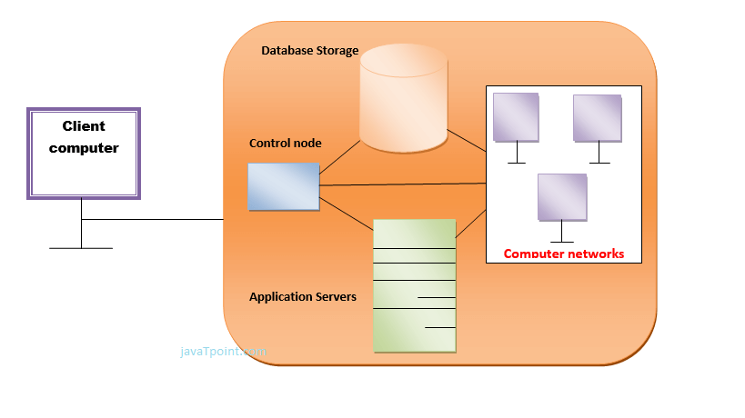
In a cloud computing system, there is a significant workload shift. Local computers have no longer to do all the heavy lifting when it comes to run applications. But cloud computing can handle that much heavy load easily and automatically. Hardware and software demand on the user's side decrease. The only thing the user's computer requires to be able to run is the cloud computing interface software of the system, which can be as simple as a Web browser and the cloud's network takes care of the rest.

  - Cloud Computing Applications
Cloud service providers provide various applications in the field of art, business, data storage and backup services, education, entertainment, management, social networking, etc.
The most widely used cloud computing applications are given below -
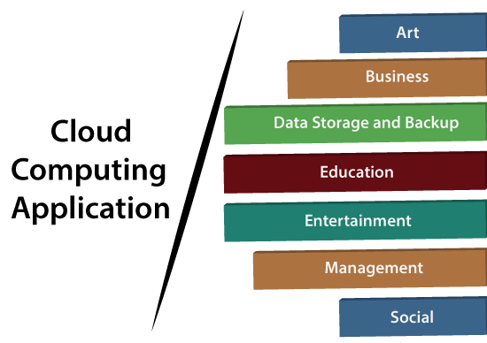
1. Art Applications
Cloud computing offers various art applications for quickly and easily design attractive cards, booklets, and images. Some most commonly used cloud art applications are given below:
- Moo
How to find Nth Highest Salary in SQL
Moo is one of the best cloud art applications. It is used for designing and printing business cards, postcards, and mini cards.
ii. Vistaprint
Vistaprint allows us to easily design various printed marketing products such as business cards, Postcards, Booklets, and wedding invitations cards.
iii. Adobe Creative Cloud
Adobe creative cloud is made for designers, artists, filmmakers, and other creative professionals. It is a suite of apps which includes PhotoShop image editing programming, Illustrator, InDesign, TypeKit, Dreamweaver, XD, and Audition.

2. Business Applications
Business applications are based on cloud service providers. Today, every organization requires the cloud business application to grow their business. It also ensures that business applications are 24*7 available to users.
There are the following business applications of cloud computing -
i. MailChimp
MailChimp is an email publishing platform which provides various options to design, send, and save templates for emails.
iii. Salesforce
Salesforce platform provides tools for sales, service, marketing, e-commerce, and more. It also provides a cloud development platform.
iv. Chatter
Chatter helps us to share important information about the organization in real time.
v. Bitrix24
Bitrix24 is a collaboration platform which provides communication, management, and social collaboration tools.
vi. Paypal
Paypal offers the simplest and easiest online payment mode using a secure internet account. Paypal accepts the payment through debit cards, credit cards, and also from Paypal account holders.
vii. Slack
Slack stands for Searchable Log of all Conversation and Knowledge. It provides a user-friendly interface that helps us to create public and private channels for communication.
viii. Quickbooks
Quickbooks works on the terminology "Run Enterprise anytime, anywhere, on any device." It provides online accounting solutions for the business. It allows more than 20 users to work simultaneously on the same system.
3. Data Storage and Backup Applications
Cloud computing allows us to store information (data, files, images, audios, and videos) on the cloud and access this information using an internet connection. As the cloud provider is responsible for providing security, so they offer various backup recovery application for retrieving the lost data.
A list of data storage and backup applications in the cloud are given below –

i. Box.com
Box provides an online environment for secure content management, workflow, and collaboration. It allows us to store different files such as Excel, Word, PDF, and images on the cloud. The main advantage of using box is that it provides drag & drop service for files and easily integrates with Office 365, G Suite, Salesforce, and more than 1400 tools.
ii. Mozy
Mozy provides powerful online backup solutions for our personal and business data. It schedules automatically back up for each day at a specific time.
iii. Joukuu
Joukuu provides the simplest way to share and track cloud-based backup files. Many users use joukuu to search files, folders, and collaborate on documents.
iv. Google G Suite
Google G Suite is one of the best cloud storage and backup application. It includes Google Calendar, Docs, Forms, Google+, Hangouts, as well as cloud storage and tools for managing cloud apps. The most popular app in the Google G Suite is Gmail. Gmail offers free email services to users.
4. Education Applications
Cloud computing in the education sector becomes very popular. It offers various online distance learning platforms and student information portals to the students. The advantage of using cloud in the field of education is that it offers strong virtual classroom environments, Ease of accessibility, secure data storage, scalability, greater reach for the students, and minimal hardware requirements for the applications.
There are the following education applications offered by the cloud -
i. Google Apps for Education
Google Apps for Education is the most widely used platform for free web-based email, calendar, documents, and collaborative study.
ii. Chromebooks for Education
Chromebook for Education is one of the most important Google's projects. It is designed for the purpose that it enhances education innovation.
iii. Tablets with Google Play for Education
It allows educators to quickly implement the latest technology solutions into the classroom and make it available to their students.
iv. AWS in Education
AWS cloud provides an education-friendly environment to universities, community colleges, and schools.

5. Entertainment Applications
Entertainment industries use a multi-cloud strategy to interact with the target audience. Cloud computing offers various entertainment applications such as online games and video conferencing.
i. Online games
Today, cloud gaming becomes one of the most important entertainment media. It offers various online games that run remotely from the cloud. The best cloud gaming services are Shaow, GeForce Now, Vortex, Project xCloud, and PlayStation Now.
ii. Video Conferencing Apps
Video conferencing apps provides a simple and instant connected experience. It allows us to communicate with our business partners, friends, and relatives using a cloud-based video conferencing. The benefits of using video conferencing are that it reduces cost, increases efficiency, and removes interoperability.
6. Management Applications
Cloud computing offers various cloud management tools which help admins to manage all types of cloud activities, such as resource deployment, data integration, and disaster recovery. These management tools also provide administrative control over the platforms, applications, and infrastructure.
Some important management applications are -
i. Toggl
Toggl helps users to track allocated time period for a particular project.
ii. Evernote
Evernote allows we to sync and save were recorded notes, typed notes, and other notes in one convenient place. It is available for both free as well as a paid version.
It uses platforms like Windows, macOS, Android, iOS, Browser, and Unix.
iii. Outright
Outright is used by management users for the purpose of accounts. It helps to track income, expenses, profits, and losses in real-time environment.
iv. GoToMeeting
GoToMeeting provides Video Conferencing and online meeting apps, which allows we to start a meeting with wer business partners from anytime, anywhere using mobile phones or tablets. Using GoToMeeting app, we can perform the tasks related to the management such as join meetings in seconds, view presentations on the shared screen, get alerts for upcoming meetings, etc.

7. Social Applications
Social cloud applications allow a large number of users to connect with each other using social networking applications such as Facebook, Twitter, LinkedIn, etc.
There are the following cloud based social applications -
i. Facebook
Facebook is a social networking website which allows active users to share files, photos, videos, status, more to their friends, relatives, and business partners using the cloud storage system. On Facebook, we will always get notifications when our friends like and comment on the posts.
ii. Twitter
Twitter is a social networking site. It is a microblogging system. It allows users to follow high profile celebrities, friends, relatives, and receive news. It sends and receives short posts called tweets.
iii. Yammer
Yammer is the best team collaboration tool that allows a team of employees to chat, share images, documents, and videos.
iv. LinkedIn
LinkedIn is a social network for students, freshers, and professionals.

  - Cloud Deployment Models/Types of Cloud:
There are the following 4 types of cloud that you can deploy according to the organization's needs-
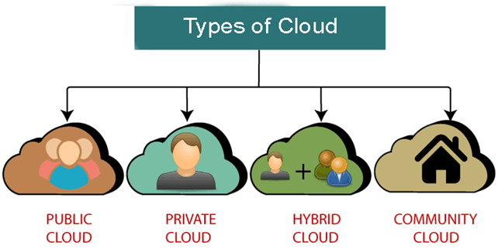

- Public Cloud
- Public cloud is open to all to store and access information via the Internet using the pay-per-usage method.
- In public cloud, computing resources are managed and operated by the Cloud Service Provider (CSP).
Example: Amazon elastic compute cloud (EC2), IBM Smart Cloud Enterprise, Microsoft, Google App Engine, Windows Azure Services Platform.
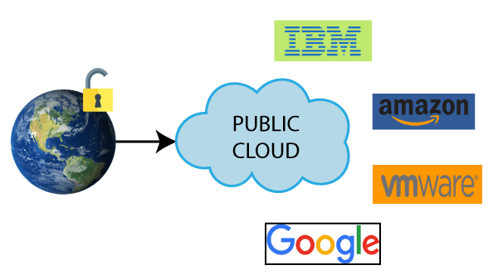
Advantages of Public Cloud
There are the following advantages of Public Cloud -
- Public cloud is owned at a lower cost than the private and hybrid cloud.
- Public cloud is highly scalable as per the requirement of computing resources.
- It is accessible by the general public, so there is no limit to the number of users.
Disadvantages of Public Cloud
- Public Cloud is less secure because resources are shared publicly.
- Performance depends upon the high-speed internet network link to the cloud provider.
- The Client has no control of data.

- Private Cloud
- Private cloud is also known as an internal cloud or corporate cloud. It is used by organizations to build and manage their own data centres internally or by the third party. It can be deployed using Opensource tools such as Open stack and Eucalyptus.
- Based on the location and management, National Institute of Standards and Technology (NIST) divide private cloud into the following two parts-
On-premise private cloud
Outsourced private cloud
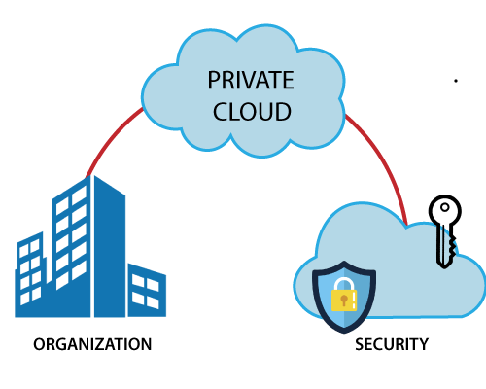
Advantages of Private Cloud
- Private cloud provides a high level of security and privacy to the users.
- Private cloud offers better performance with improved speed and space capacity.
- It allows the IT team to quickly allocate and deliver on-demand IT resources.
Disadvantages of Private Cloud
- Skilled people are required to manage and operate cloud services.
- Private cloud is accessible within the organization, so the area of operations is limited.
- Private cloud is not suitable for organizations that have a high user base, and organizations that do not have the prebuilt infrastructure, sufficient manpower to maintain and manage the cloud.

- Hybrid Cloud
- Hybrid Cloud is a combination of the public cloud and the private cloud. we can say: Hybrid Cloud = Public Cloud + Private Cloud
- Hybrid cloud is partially secure because the services which are running on the public cloud can be accessed by anyone, while the services which are running on a private cloud can be accessed only by the organization's users.
Example: Google Application Suite (Gmail, Google Apps, and Google Drive), Office 365 (MS Office on the Web and One Drive), Amazon Web Services.
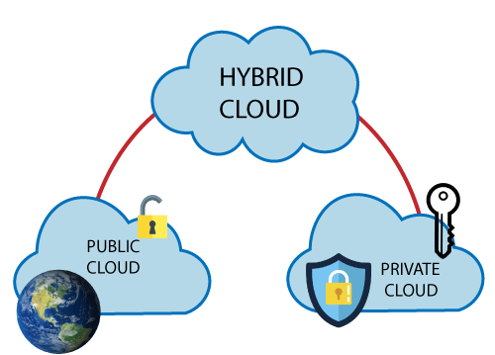
Advantages of Hybrid Cloud
- Hybrid cloud is suitable for organizations that require more security than the public cloud.
- Hybrid cloud helps you to deliver new products and services more quickly.
- Hybrid cloud provides an excellent way to reduce the risk.
- Hybrid cloud offers flexible resources because of the public cloud and secure resources because of the private cloud.
Disadvantages of Hybrid Cloud
- In Hybrid Cloud, security feature is not as good as the private cloud.
- Managing a hybrid cloud is complex because it is difficult to manage more than one type of deployment model.
- In the hybrid cloud, the reliability of the services depends on cloud service providers.

- Community Cloud
- Community cloud allows systems and services to be accessible by a group of several organizations to share the information between the organization and a specific community. It is owned, managed, and operated by one or more organizations in the community, a third party, or a combination of them.
Example: Health Care community cloud
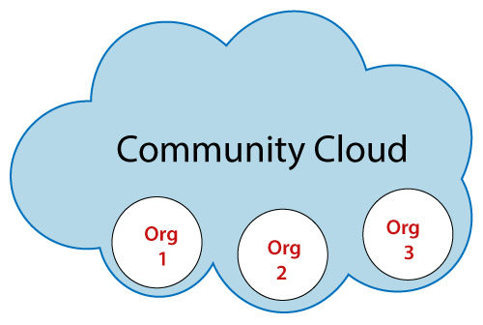
Advantages of Community Cloud
- Community cloud is cost-effective because the whole cloud is being shared by several organizations or communities.
- Community cloud is suitable for organizations that want to have a collaborative cloud with more security features than the public cloud.
- It provides better security than the public cloud.
- It provides collaborative and distributive environment.
- Community cloud allows us to share cloud resources, infrastructure, and other capabilities among various organizations.
Disadvantages of Community Cloud
- Community cloud is not a good choice for every organization.
- Security features are not as good as the private cloud.
- It is not suitable if there is no collaboration.
- The fixed amount of data storage and bandwidth is shared among all community members.

  - Cloud Service Models/Types of Cloud Services:
There are the following three types of cloud service models -
Infrastructure as a Service (IaaS)
Platform as a Service (PaaS)
Software as a Service (SaaS)

- Infrastructure as a Service (IaaS)
- IaaS is also known as Hardware as a Service (HaaS). It is a computing infrastructure managed over the internet. The main advantage of using IaaS is that it helps users to avoid the cost and complexity of purchasing and managing the physical servers.

Characteristics of IaaS
- Resources are available as a service
- Services are highly scalable
- Dynamic and flexible
- GUI and API-based access
- Automated administrative tasks
Example: Digital Ocean, Linode, Amazon Web Services (AWS), Microsoft Azure, Google Compute Engine (GCE), Rackspace, and Cisco Meta cloud.
- Platform as a Service (PaaS)
- PaaS cloud computing platform is created for the programmer to develop, test, run, and manage the applications.
Characteristics of PaaS
- Accessible to various users via the same development application.
- Integrates with web services and databases.
- Builds on virtualization technology, so resources can easily be scaled up or down as per the organization's need.
- Support multiple languages and frameworks.
- Provides an ability to "Auto-scale".
Example: AWS Elastic Beanstalk, Windows Azure, Heroku, Force.com, Google App Engine, Apache Stratos, Magento Commerce Cloud, and OpenShift.
- Software as a Service (SaaS)
- SaaS is also known as "on-demand software". It is a software in which the applications are hosted by a cloud service provider. Users can access these applications with the help of internet connection and web browser.

Characteristics of SaaS
- Managed from a central location
- Hosted on a remote server
- Accessible over the internet
- Users are not responsible for hardware and software updates. Updates are applied automatically.
- The services are purchased on the pay-as-per-use basis
Example: BigCommerce, Google Apps, Salesforce, Dropbox, ZenDesk, Cisco WebEx, ZenDesk, Slack, and GoToMeeting.

Difference between IaaS, PaaS, and SaaS
The below table shows the difference between IaaS, PaaS, and SaaS -
IaaS | Paas | SaaS
It provides a virtual data center to store information and create platforms for app development, testing, and deployment. | It provides virtual platforms and tools to create, test, and deploy apps. | It provides web software and apps to complete business tasks.
It provides access to resources such as virtual machines, virtual storage, etc. | It provides runtime environments and deployment tools for applications. | It provides software as a service to the end-users.
It is used by network architects. | It is used by developers. | It is used by end users.
IaaS provides only Infrastructure. | PaaS provides Infrastructure+Platform. | SaaS provides Infrastructure+Platform +Software.

  - Cloud Computing Characteristics:
- Shared Infrastructure — Uses a virtualized software model, enabling the sharing of physical services, storage, and networking capabilities. The cloud infrastructure, regardless of deployment model, seeks to make the most of the available infrastructure across a number of users.
- Dynamic Provisioning / on demand self-service — Allows for the provision of services based on current demand requirements. This is done automatically using software automation, enabling the expansion and contraction of service capability, as needed. This dynamic scaling needs to be done while maintaining high levels of reliability and security.
- Broad Network Access — Needs to be accessed across the internet from a broad range of devices such as PCs, laptops, and mobile devices, using standards-based APIs (for example, ones based on HTTP). Deployments of services in the cloud include everything from using business applications to the latest application on the newest smartphones.
- Multi-Tenant Capable - The resources (e.g., network, storage and compute power) can be shared among multiple enterprise clients, thereby lowering overall expense. Resource virtualization is used to enforce isolation and aid in security.
- Rapid Elasticity - The consumer should have the ability to rapidly (often automatically) increase or decrease the computing resources needed to carry out their work.
- Managed Metering / Measured Service - Uses metering for managing and optimizing the service and to provide reporting and billing information. In this way, consumers are billed for services according to how much they have actually used during the billing period. In short, cloud computing allows for the sharing and scalable deployment of services, as needed, from almost any location, and for which the customer can be billed based on actual usage.
  - Ethical issues in Cloud Computing:
Cloud computing is based on a paradigm shift with profound implications on computing ethics. The main elements of this shift are:
- the control is given to third party services;
- the data is stored on multiple sites administered by several organizations; and
- multiple services interoperate across the network.

Unauthorized access, data corruption, infrastructure failure, or unavailability are some of the risks related to relinquishing the control to third party services; moreover, it is difficult to identify the source of the problem and the entity causing it. Systems can span the boundaries of multiple organizations and cross the security borders, a process called reparameterization. As a result of de-parameterisation “not only the border of the organizations IT infrastructure blurs, also the border of the accountability becomes less clear”.
The complex structure of cloud services can make it difficult to determine who is responsible in case something undesirable happens. In a complex chain of events or systems, many entities contribute to an action with undesirable consequences, some of them have the opportunity to prevent these consequences, and therefore no one can be held responsible, the so-called “problem of many hands.”

Ubiquitous and unlimited data sharing and storage among organizations test the self-determination of information, the right or ability of individuals to exercise personal control over the collection, use and disclosure of their personal data by others; this tests the confidence and trust in today’s evolving information society. Identity fraud and theft are made possible by the unauthorized access to personal data in circulation and by new forms of dissemination through social networks and they could also pose a danger to cloud computing.

The question of what can be done proactively about ethics of cloud computing does not have easy answers as many undesirable phenomena in cloud computing will only appear in time. But the need for rules and regulations for the governance of cloud computing are obvious. The term governance means the manner in which something is governed or regulated, the method of management, the system of regulations. Explicit attention to ethics must be paid by governmental organizations providing research funding; private companies are less constraint by ethics oversight and governance arrangements are more conducive to profit generation.

Accountability is a necessary ingredient of cloud computing; adequate information about how data is handled within the cloud and about allocation of responsibility are key elements to enforcing ethics rules in cloud computing. Recorded evidence allows us to assign responsibility; but there can be tension between privacy and accountability and it is important to establish what is being recorded, and who has access to the records.

Unwanted dependency on a cloud service provider, the so-called vendor lock-in, is a serious concern and the current standardization efforts at NIST attempt to address this problem. Another concern for the users is a future with only a handful of companies which dominate the market and dictate prices and policies
  - Vulnerabilities/Threat to Cloud Computing:
- Misconfigured Cloud Storage
- Loss or Theft of Intellectual Property
- Loss of Control Over End-User Actions
- Poor Access Management
- Insecure APIs

